# Exploring Linear Oscillators: Simple Harmonic Motion and Beyond

## 2024EV0563

**INFORMATION SCIENCE AND ENGINEERING**

## SABARISH O M 7376231SE145

1. **INTRODUCTION:**

Linear oscillators are fundamental in understanding various physical systems and phenomena. From simple pendulums to sophisticated electrical circuits, the principles of linear oscillation are widely applicable. This assignment explores linear oscillators, focusing on simple harmonic motion (SHM) and extending to more complex oscillatory systems. We will delve into the theoretical foundations, practical applications, and advanced topics beyond simple harmonic motion.

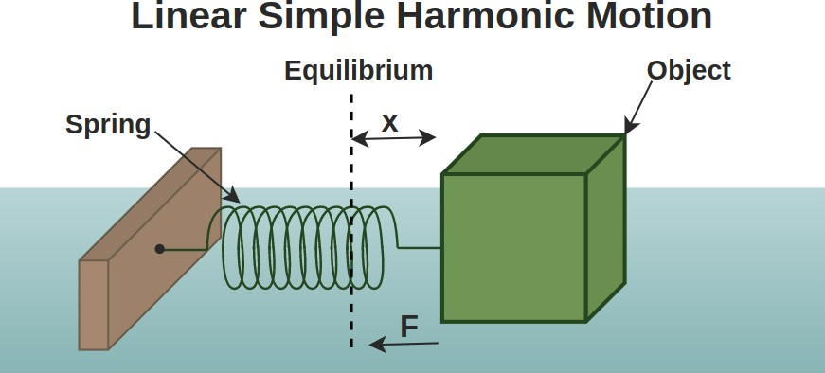

Figure 1:Linear Simple Harmonic Motion.

## HARMOSIMPLE NIC MOTION (SHM):

**Definition and Characteristics**

Simple Harmonic Motion (SHM) is a type of periodic motion where an object oscillates back and forth through an equilibrium position under the influence of a restoring force. This force is proportional to the displacement of the object from its equilibrium position and acts in the opposite direction. The key characteristics of SHM include:

* + - Restoring Force: The force that brings the object back to its equilibrium position.
    - Sinusoidal Motion: The displacement of the object follows a smooth, repetitive oscillation over time.
* Constant Frequency and Period: The frequency (number of oscillations per unit time) and period (time taken for one complete oscillation) remain constant.

## Energy in SHM

In SHM, the total mechanical energy remains constant and is the sum of kinetic and potential

energy. The kinetic energy is due to the motion of the object, while the potential energy is due to its position relative to the equilibrium. As the object oscillates, energy continually shifts between kinetic and potential forms.

### Examples of SHM

1. Mass-Spring System: A mass attached to a spring exhibits SHM when displaced from its equilibrium position.
2. Simple Pendulum: For small angles, a simple pendulum approximates SHM, oscillating back and forth under the influence of gravity.

## DAMPED HARMONIC MOTION:

In real-world systems, oscillations are often subject to damping forces, which cause the amplitude of motion to decrease over time. Damping can be classified into three types:

* + - 1. Underdamped: Oscillations gradually diminish but continue to oscillate before stopping.
      2. Critically Damped: The system returns to equilibrium as quickly as possible without oscillating.
      3. Overdamped: The system returns to equilibrium slowly without oscillating.

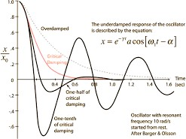

Figure 2:DAMPED HARMONIC MOTION

### Energy Dissipation

In damped systems, energy dissipates over time, usually converted into heat or other forms of

energy loss. The rate of energy dissipation depends on the damping forces acting on the system.

### Driven Harmonic Motion

Driven harmonic motion occurs when an external periodic force is applied to the system. This results in forced oscillations, where the system oscillates at the frequency of the driving force rather than its natural frequency.

### Resonance

Resonance occurs when the driving frequency matches the natural frequency of the system. At resonance, the amplitude of oscillation reaches a maximum, which can lead to large oscillations and potential structural failure in mechanical systems**.**

## BEYOND SIMPLE HARMONIC MOTION:

### Nonlinear Oscillators

Real-world systems often exhibit nonlinearities, where the restoring force is not directly proportional to displacement. Nonlinear oscillators can exhibit a wide range of behaviors, including bifurcations, chaos, and more complex periodic motions.

### Duffing Oscillator

The Duffing oscillator is an example of a nonlinear oscillator, which includes a term that introduces nonlinearity, leading to rich dynamics such as bistability (two stable states) and chaos (sensitive dependence on initial conditions).

### Coupled Oscillators

When two or more oscillators are coupled, they can exchange energy, leading to phenomena such as beat frequencies, synchronization, and normal modes.

## QUANTUM HARMONIC OSCILLATOR:

In quantum mechanics, the harmonic oscillator model is crucial for understanding the behavior of particles in potential wells. The quantum harmonic oscillator has quantized energy levels,

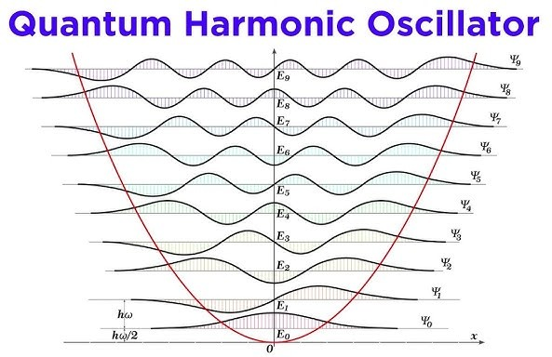meaning that the energy of the system can only take on certain discrete values.

Figure 3:Quantum Harmonic Oscillation.

### Electrical Oscillators

Electrical circuits can also exhibit oscillatory behavior, with the LC circuit (inductor-capacitor circuit) being a classic example. In an LC circuit, the oscillation of charge and current mirrors the behavior of mechanical oscillators.

### Applications

* + 1. Engineering: Understanding oscillatory behavior is crucial in designing structures to withstand vibrations and avoid resonance-induced failures.
    2. Medical Devices: Oscillatory principles are used in medical devices like pacemakers and MRI machines.
    3. Seismology: The study of earthquake waves relies on understanding the oscillatory nature of seismic waves.
    4. Quantum Mechanics: The quantum harmonic oscillator model is foundational in understanding molecular vibrations and quantum field theory.
    5. Communication Systems: Electrical oscillators are integral in radio transmission and signal processing.

## CONCLUSION:

The study of linear oscillators, starting from simple harmonic motion and extending to more complex systems, provides deep insights into a wide range of physical phenomena. From

mechanical systems to electrical circuits and quantum mechanics, the principles of oscillation are universally applicable. By understanding both the simple and advanced aspects of oscillatory motion, we can better analyze, design, and innovate across various scientific and engineering domains. This assignment has explored the theoretical foundations, practical applications, and

advanced topics of linear oscillators, highlighting their importance in both classical and modern physics.

## BIBLIOGRAPHY:

https://byjus.com/jee/simple-harmonic-motion-shm/

# DYNAMIC ARRAY TO STORE STUDENT RECORDS

## 2024EV0578

**INFORMATION SCIENCE AND ENGINEERING**

## SABARISH O M 7376231SE145

1. **INTRODUCTION**

In modern educational institutions, managing student records efficiently is critical. With the advent of technology, data management has shifted from traditional paper-based systems to

digital databases. One of the essential data structures for managing student records in a flexible and scalable way is the dynamic array. This assignment aims to explore the implementation and utilization of a dynamic array to store student records, highlighting its advantages, functionalities, and applications.

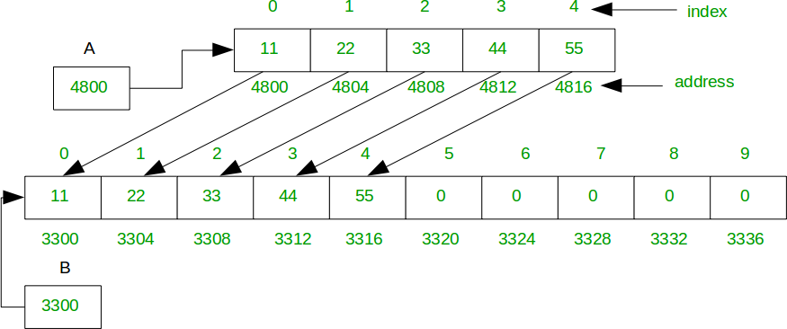

Figure 1:How a dynamic array works.

## WHAT IS A DYNAMIC ARRAY?

A dynamic array is a data structure that can dynamically resize itself to accommodate varying

amounts of data. Unlike static arrays, which have a fixed size, dynamic arrays can grow or shrink

as needed. This flexibility makes dynamic arrays particularly useful for applications where the number of elements is not known in advance or fluctuates frequently.

## CHARACTERISTICS OF DYNAMIC ARRAYS

* + - 1. Resizing: Dynamic arrays can resize themselves when they run out of space. This typically involves creating a new, larger array and copying the elements from the old array to the new one.
      2. Amortized Constant Time Complexity: While resizing involves copying elements, which is an O(n) operation, this does not happen frequently. Over many insertions, the average time complexity for adding an element remains O(1).
      3. Contiguous Memory Allocation: Elements in a dynamic array are stored in contiguous memory locations, which allows for efficient access and cache utilization.

## 2 STRUCTURE OF STUDENT RECORDS

To manage student records effectively, we need to define the structure of a student record. A student record typically contains the following information:

1. Student ID: A unique identifier for each student.
2. Name: The full name of the student.
3. Age: The age of the student.
4. Grade: The current grade or year of the student.
5. GPA: The Grade Point Average of the student.
6. Address: The residential address of the student.

## Implementation of a Dynamic Array for Student Records

We will implement a dynamic array in Python to store student records. The dynamic array will support operations such as adding a new student, deleting a student, and retrieving student information.

## Advantages of Using Dynamic Arrays

1. Flexible Size Management: Dynamic arrays can grow and shrink in size, making them suitable for applications where the number of elements varies over time.

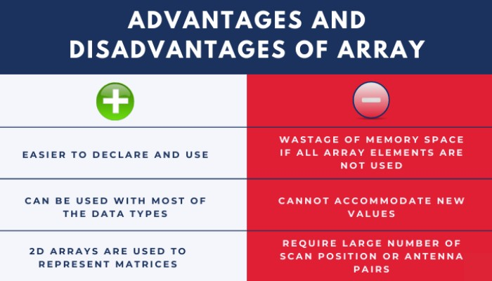

Figure 2 :Advantages and disadvantages of dynamic array

1. Efficient Access: With contiguous memory allocation, dynamic arrays provide fast access to elements using indices.
2. Amortized Time Complexity: Despite occasional resizing, the average time complexity for adding an element is O(1).

## Applications in Student Records Management

Dynamic arrays are particularly useful in student records management for the following reasons:

* + 1. Scalability: As the number of students grows or shrinks, the dynamic array can adjust its size accordingly.
    2. Performance: Quick access and modification of records ensure that operations like searching, updating, and deleting are efficient.
    3. Simplicity: Dynamic arrays are simpler to implement compared to other complex data structures like linked lists or trees.

## Efficient Enrollment and Registration Systems

Dynamic arrays are particularly well-suited for handling the enrollment and registration processes in educational institutions. As new students enroll, their records can be added to the dynamic array without worrying about the initial capacity of the array. If the array reaches its current capacity, it automatically resizes, ensuring that there is always space for new student records.

## Dynamic Class Management

Dynamic arrays can be used to manage the lists of students in different classes or courses. As

students register for or drop classes, the dynamic array can adjust its size to reflect these changes. This flexibility ensures that each class roster can grow or shrink dynamically without performance degradation.

## Dynamic Academic Record Keeping

Academic records such as grades, GPAs, and other performance metrics can be stored and dynamically updated using dynamic arrays. As students complete courses and receive grades, their academic records can be updated efficiently. This is particularly useful for maintaining up-to-date transcripts and performance reports.

## Efficient Alumni Tracking and Engagement

Dynamic arrays can be used to maintain records of alumni, including their contact information, graduation dates, and professional achievements. As alumni information changes over time, such as changes in contact details or career advancements, the dynamic array can efficiently handle these updates.

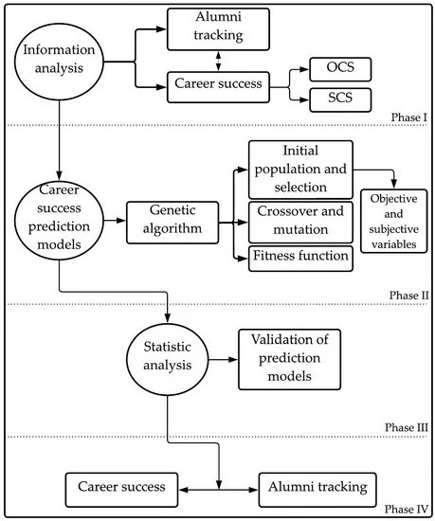

Figure 3**:**Alumni Tracking

## Conclusion

Dynamic arrays provide an efficient and flexible way to manage student records. Their ability to resize dynamically, coupled with efficient access and modification operations, makes them ideal for applications in educational institutions. By implementing a dynamic array to store student records, we can ensure scalable and performant management of student data, which is crucial for modern educational systems.

## BIBLIOGRAPHY:

[https://www.geeksfor](http://www.geeksforgeeks.org/dynamic-array-in-c/)geeks.or[g/dynamic-array-in-c/](http://www.geeksforgeeks.org/dynamic-array-in-c/)